How to revise

Below is the revision clock structure that we advise pupils to use when structuring and organising their revision, alongside some suggested revision techniques. Videos of the revision techniques can be found on the BAA website on the QR code below – there are also resources for all subjects based around the revision clock.

Stage 1: Review:

When you are reviewing a topic area this should take a quarter of the time you have allocated to revise. Some techniques you could use are:

* Mind maps and graphic organisers.
* Flashcards – use the Leitner system to use them effectively.

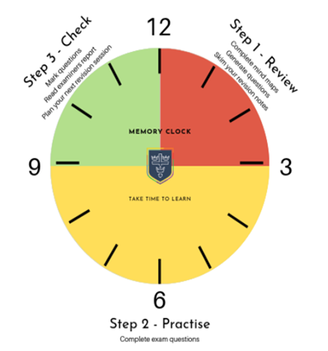

Stage 2: Practise:

This is the time when you should practise exam questions; it should last half of your revision time. This section is to see if you can apply the material reviewed to exam questions. This could also include using the questions available on platforms such as Seneca and GCSE Pod.

Stage 3: Check:

This is when you mark the questions and see which areas you are good at and which you need more time on. This should take a quarter of the time. Make an action plan for your next session.

Online revision resources we recommend:



Seneca

BAA revision hub

GCSE Pod

Sparx maths

